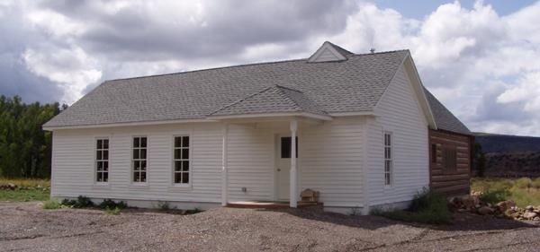
Team Name/Sponsor:
TTTT

Address: City/State/Zip:

Phone: Email:

Team Captain:

Address: City/State/Zip:

Phone: Email:

Team Members & phone numbers:

Cost: $500 per team, maximum of 4 team members, for the 2-day tournament, payable upon submission of your entry form.
Sorry, no refunds unless we already have 12 teams signed up. Entry fee entitles you to use 2 of your own personal flies of your choice per day with the option to purchase the use of a third fly for $25 and a fourth fly for
$25 each day.

Send entry form and fee to: WRCA
P.O. Box 751, Meeker, CO 81641 (970) 878-5677
Community Association
P O Box 751
Meeker, CO 81641
Betsie Thompson
970-361-1516
Mike Sizemore 970-878-4368
Callie Scritchfield
970-250-6825
Contact us if you would like to be a volunteer judge for a team!

For more information visit: www.meekercolorado.com or

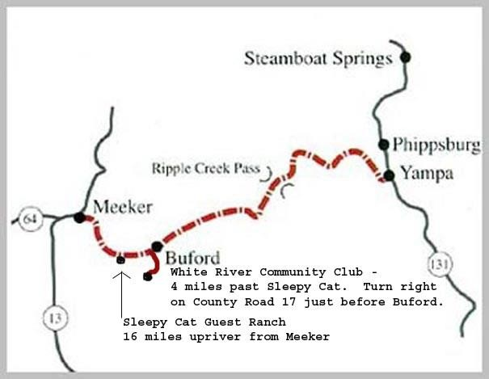
WRCA Board Members: Betsie Thompson, President
Mike Sizemore, Vice President Callie Scritchfield, Secretary/Treasurer
Dee Weiss, Historian
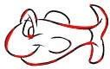

The Buford School
19th Annual Buy-Fly Fishing Tournament

March 9-10, 2024
Meeker, CO

The White River Community Association has been meeting together for good food, fellowship, and neighborly support for the past 54 years. Rich with history, the group has continued the traditions begun when the group began to meet in 1961. Gatherings are held, usually the 2nd Sunday of the month, at the Old Buford Schoolhouse near Buford on County Road
17. Over time, the faces and personalities of the members may change; but the lively experience of the get-together has not diminished.
In 2005, the members decided to host a buy-fly fishing tournament to secure the fish for the association’s annual fish fry. Mark Scritchfield initiated the plans & worked with the group to put on the inaugural tournament. The purpose of the tournament is three-fold: raise money for the sustainability of the historic Buford School, secure the white fish for the annual WRCA Fish Fry & provide a fun, competitive opportunity for the community.

THE TOURNAMENT
The 2-day event will be held March 9-10, 2024. Hours: Saturday 8:00 a.m. – 3:30 p.m. and Sunday 7:00 a.m. – 1:00 p.m.
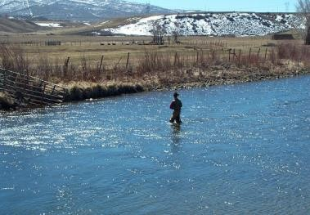
Check in for teams and judges Saturday at 7:00 a.m. at The Buford School. Sunday you will meet at your fishin’ hole. Advertising will include all sponsors; landowners contacted; team sponsors solicited; judges invited and prizes gathered.
1st, 2nd, & 3rd place prizes will be awarded. An individual prize will also be awarded. Prizes are based on the total weight of the white fish fillets caught for a 2-day total with all fillets becoming property of the association for the June Fish Fry. Each team will have a judge with them.

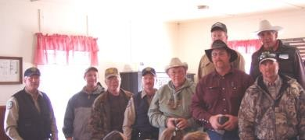

FOOD & FUN
Lunch will be provided on Saturday and we’ll have a chili dinner on Sunday, immediately following the weigh-in along with the awarding of the top prizes.

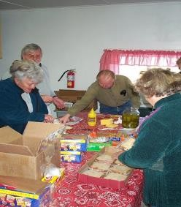

WORKING TOGETHER
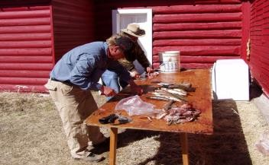
Rain, snow or shine, anglers will set out to catch the area’s famous white fish. The fishermen will fillet their catch each day & bring them in for weighing and give them to WRCA members for freezing.

On Sunday, after the tournament, association members, fishermen, judges, and their families will be treated to a homemade chili dinner with all the “fixins,” as well as a variety of desserts.
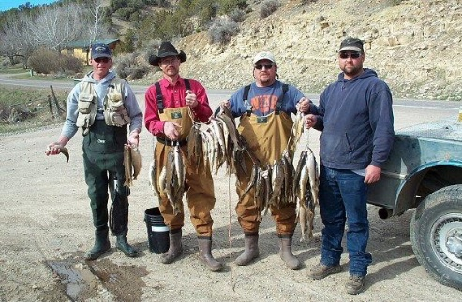

SPONSORSHIP OPPORTUNITIES:
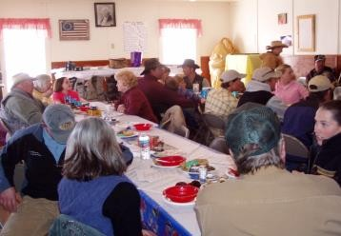
All sponsors of the event will be featured in the advertising prior to the event, on posters at the event, & in all the articles following the event. The White River Community Association is proud of the community spirit with which landowners, area merchants, business owners, & members have rallied around this event to make it so much fun for all who participate & attend.

Make plans now to participate in this community event. There will only be room for 12 teams to participate; so ENTER EARLY to secure a spot.

